Project Design Phase-II
Data Flow Diagram s User Stories

User Type | Functional  Requiremen t (Epic) | User Stor y No | User Story  / Task | Acceptance  Criteria | Priorit y | Releas e
Customer  (Mobile User) | Registration | USN  -1 | As a user, I can register using email | User can  access | High | Sprint-  1

Date | 20 February 2026
Team ID | LTVIP2026TMIDS79334
Project Name | Empowering India: Analysing the Evolution of Union Budget Allocations for  Sustainable Growth
Maximum  Marks | 4 Marks

dashboard after registration.
Data Flow Diagrams:
 |  |  | & password.
Customer  (Mobile User) | Registration | USN  -2 | As a user, I receive confirmatio n email after registration. | Confirmation link works successfully. | High | Sprint-  1
Customer  (Mobile User) | Registration | USN  -3 | As a user, I can register through  Facebook. | User logs in via Facebook  successfully. | Low | Sprint-  2
Customer  (Mobile User) | Registration | USN  -4 | As a user, I can register through Gmail. | User logs in via Gmail  successfully. | Mediu m | Sprint-  1

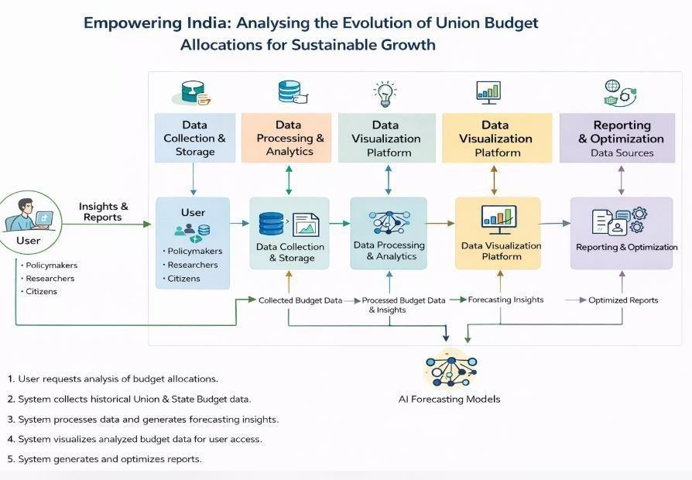
User Stories
Use the below template to list all the user stories for the product.

Customer  (Mobile User) | Login | USN  -5 | As a user, I can login using email  &  password. | Dashboard loads after login. | High | Sprint-  1
Customer  (Mobile User) | Dashboard | USN  -6 | As a user, I can view  sector-wise budget allocations. | Charts display correct allocation data. | High | Sprint-  2
Customer  (Mobile User) | Dashboard | USN  -7 | As a user, I can view  year-wise budget trends. | Trend graphs display correctly. | High | Sprint-  2
Customer  (Mobile User) | Reports | USN  -8 | As a user, I can download budget reports. | PDF report downloads successfully. | Mediu m | Sprint-  3
Customer  (Web User) | Dashboard | USN  -9 | As a web user, I can access interactive dashboards. | Dashboard loads with filters & charts. | High | Sprint-  2
Customer  (Web User) | Comparison | USN  -10 | As a user, I can compare Union & State budgets. | Comparison chart displays correctly. | Mediu m | Sprint-  3
Customer  (Web User) | Forecasting | USN  -11 | As a user, I can view  AI-based | Forecast graph shows predicted data. | Mediu m | Sprint-  3
 |  |  | future predictions.
Customer  Care  Executive | Support | USN  -12 | As a  support executive, I can respond to user queries. | Queries are resolved and marked closed. | Mediu m | Sprint-  3
Customer  Care  Executive | Feedback | USN  -13 | As a  support executive, I can view user feedback. | Feedback list is accessible. | Low | Sprint-  4
Administrato  r | Data  Management | USN  -14 | As an admin, I can upload new budget datasets. | Data uploads successfully. | High | Sprint-  1
Administrato  r | User  Management | USN  -15 | As an  admin, I can manage user accounts. | Admin can activate/deactivat e users. | Mediu m | Sprint-  2
Administrato  r | Reporting | USN  -16 | As an admin, I can generate system reports. | Reports generated successfully. | Low | Sprint-  4

